Detecting Motifs form Sequences
Yug-Jyh Hu, Dennis Kibler and Suzanne Sandmeyer
Proc. 16th International Conf. on Machine Learning, pp. 181-190, 1999
Abstract

- Introduction
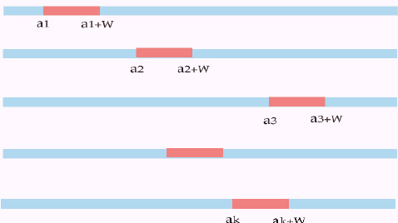
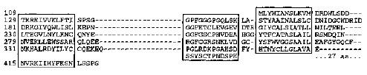
- Characteristics of Motif-finding Problem

- Patterns are relatively short since they only define a local shape.

- Patterns are not defined by an exact sequence of bases, and variation is allowed. Typically the variation is represented via a probability matrix.

- The precise location of the receptor site may not be important, as the goal of the receptor site is to bind to another molecule.

- Multiple occurrences of a receptor site may be important since each occurrence would give a molecule a greater chance of finding the binding site.

- Insertion and deletions probably do not occur, as these would have a drastic effect on the local shape of the receptor.

- The pattern or motif should be common to most of these sequences and uncommon in all sequences. It is essential that not all genes are expressed, but only a selected few. Also there may be multiple ways of turning on a gene, so it not required that the motif occur in every sequences in a given family.
- Issues in Motif-Finding Algorithms
- Representation
- Objective Function
- Search strategy
- The DMS Algorithm
Exp: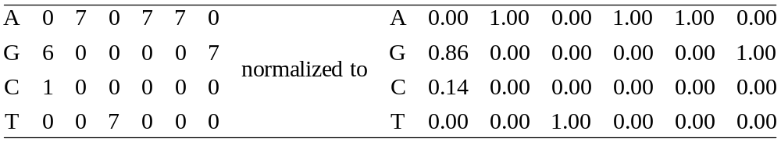
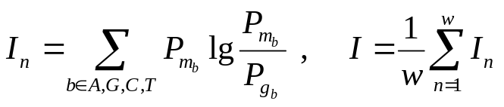
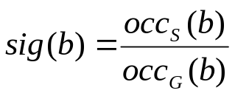
- Translation: Subsequences into Matrices
- Determining Possible Motif Occurrences
- Finding and Ranking Motif Candidates

Created by: Ieng-Jhe Liao
Date: August 6, 2002

